REMOTE SENSING AND GIS

Winter Internship Training program
Name: Penabadi Manisree
Project Title: Generating Terrain Derivatives (Contours, Slope, Aspects, and Hill shade) from DEM Satellite Data and GIS
Software Used: QGIS 3.44
Coordinate Reference system: WGS 84 / UTM Zone 45N
TERRAIN DERIVATIVE GENERATION
Aim:
To generate topographic derivates, including contours and slope maps, from a Digital Elevation Model (DEM) of the Himalayan Watershed region using QGIS to analyze terrain characteristics.

Introduction:
Terrain derivatives are fundamental products of spatial analysis in GIS. In this exercise, elevation data for Himalayan Watershed region was processed to create contours, which are lines of equal elevation that allow for the visualization of 3D landforms on a 2D map. These derivatives are essential for environmental planning and infrastructure development in mountains regions.
Data collection
The following datasets and tools were utilized:
- Source Data: Digital Elevation Model (DEM) for the Himalayan Watershed region.
- Software Tool: QGIS Extraction -> Contour tool.
- Key Attributes: Elevation (ELEV) values in meters.

Methodology

The following steps were performed in QGIS to optimize the visualization of the dense terrain data:
- Data Import: The Digital Elevation Model (DEM) of the Himalayan region was loaded into the QGIS Interface.
- Contour Extraction: Using the Raster -> Extraction -> Contour tool, elevation lines were generated at a specific interval.
- Symbology Optimization: Due to the high density of the contour lines at a small scale (1:588,670), the layer initially appeared as a solid block of color.
- Rule – based Filtering: TO improve legibility, Rule – based symbology was applied. A filter expression (e.g., “ELEV” % 100 = 0) was used to display only the Major (Index) contours.
- Refining Line Weight: The Stroke width of simple line was reduced to 0.1mm or less to prevent lines from overlapping and clearly reveal the topographic features of ridges.
- Layout Generation: The finalized map was then exported using the Print Layout manager for final presentation.

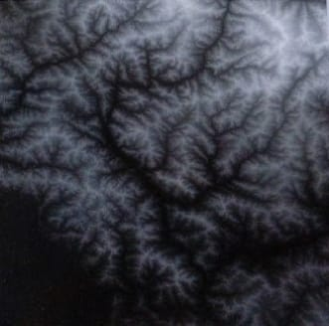
The image displays a raw Digital Elevation Model (DEM) of a Himalayan watershed region, which serves as the primary data source for the Project-4. At this stage, the data is in its original grayscale format, where pixel intensity represents elevation values ranging from approximately 297m to 6,535m. This unprocessed layer provides the foundational topographical information needed to later derive essential terrain products like Slope, Aspect, and Contour lines.
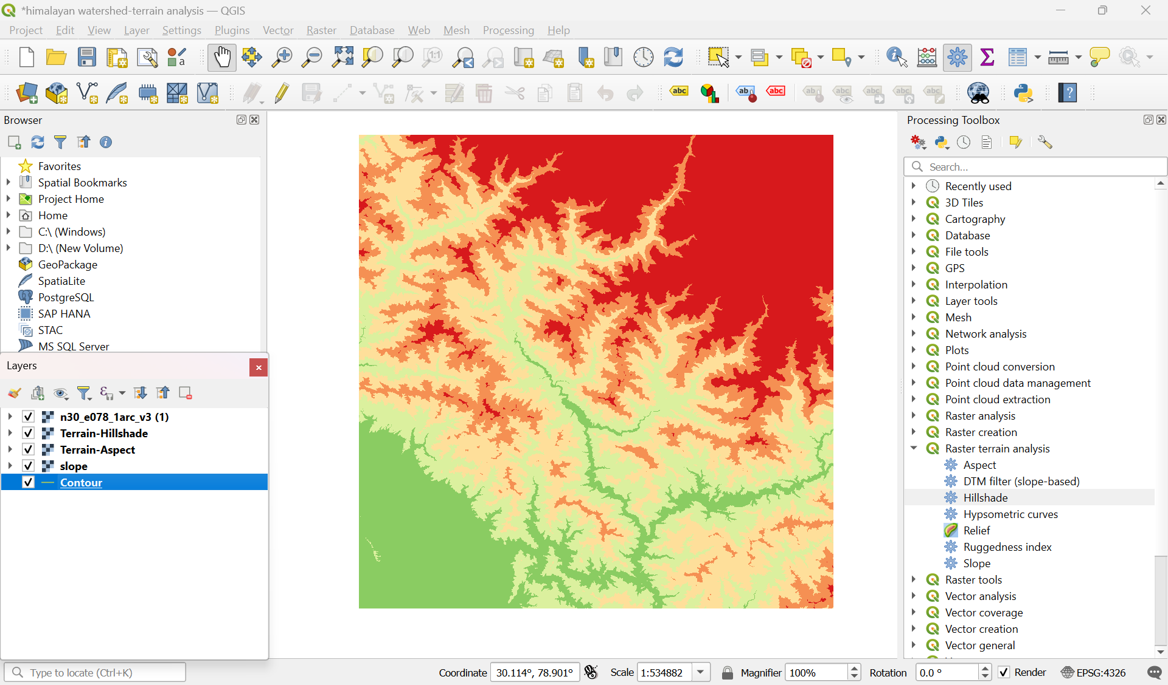
- Lower height
- Higher Elevation
The map utilizes a color-coded elevation scale to visualize topographical variation. The green regions indicate the lowest points of the watershed, such as valley bottoms and drainage networks. The red regions highlight the highest geographical features, representing the rugged mountain peaks and ridges.

Contour Lines
Contour lines are the lines that connect points of equal elevation above sea level. They allow us to visualize the height, shape, and “steepness” of the Earth’s surface on flat screen or piece of paper.
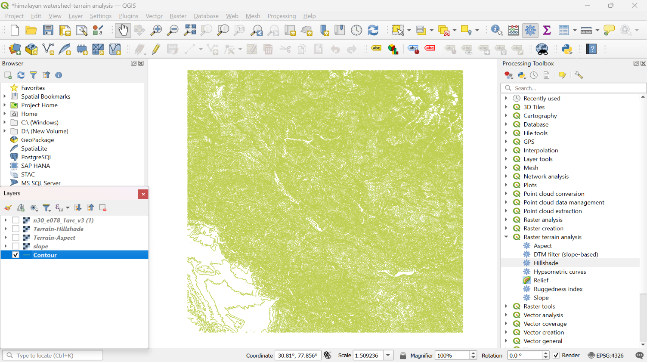
“The map includes a vector Contour Layer generated from the primary Digital Elevation Model (DEM) to provide precise topographical detail. These lines represent points of equal elevation across the Himalayan watershed, effectively visualizing the 3D shape of the terrain on a 2D surface. The density of these lines indicates the steepness of the terrain; closely spaced contours highlighting the rugged, steep mountains slopes, while wider spacing identities the more gradual inclines of the valley floors”.
Slope
Slope represents the steepness or incline of the terrain. It is calculated by measuring the change in elevation (vertical rise) over a certain distance (horizontal run).
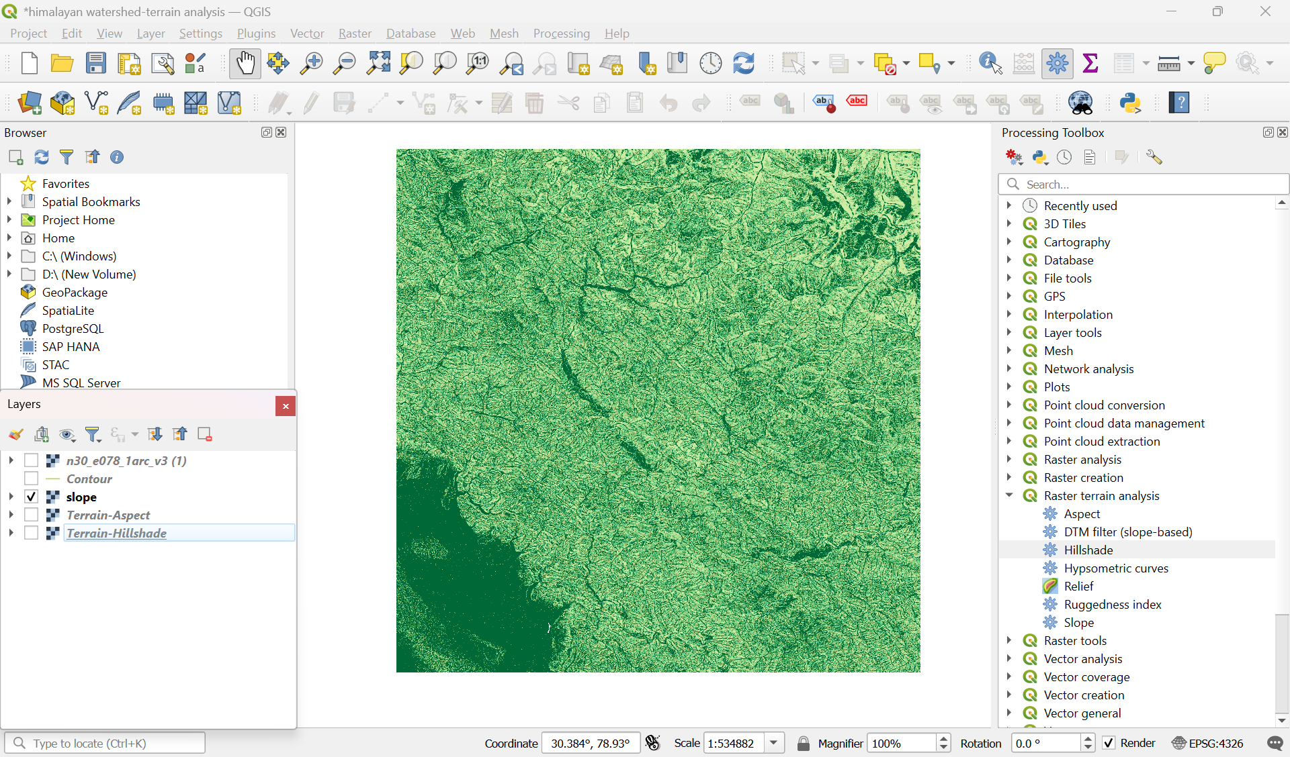
The slope map represents the rate of change in elevation across the Himalayan watershed, measured in degrees or percentage. In this visualization, the varying shades of green indicate terrain steepness, where darker, denser textures highlight vertical mountain faces and sharp ridges, while lighter areas represent more level ground such as valley basins. This analysis is critical for identifying areas prone to landslide and determining the overall ruggedness of the high-altitude terrain. Slope is a terrain derivative that calculates steepness of the Himalayan landscape by measuring the vertical change in elevation over distance. The data is essential for understanding water runoff patterns and accessing geological stability in high – altitude regions.
Aspect
In GIS and terrain analysis, Aspect is the compass direction that a terrain slopes faces. While Elevation tells us “how high” a point is and Slope tells us “how steep” it is, Aspect map shows “which way” the slope is looking (North, South, East, or West).
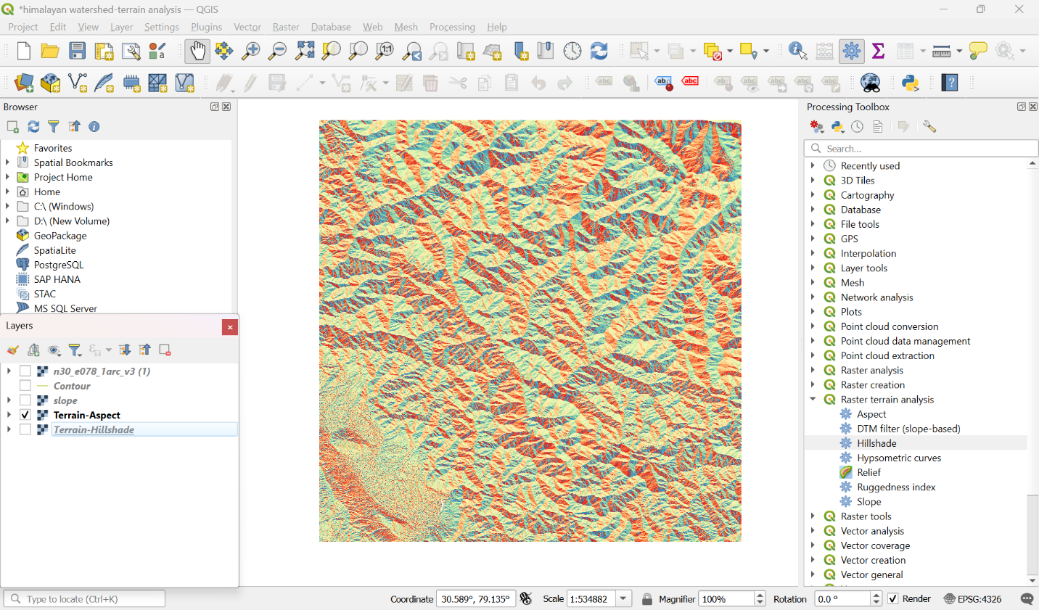
The Aspect map identifies the horizontal compass direction that each mountain slope faces within the Himalayan watershed. In this visualization, the terrain is represented by a color – coded patchwork, where each hue corresponds to a specific cardinal direction (North, East, South, or West). This analysis is vital for watershed management as it predicts solar radiation exposure and snowmelt rates; for instance, south – facing slopes in the Himalayas typically receive more direct sunlight, affecting soil moisture and local vegetation density. The varying colors represents the compass direction of the slopes, ranging from ‘0’ degrees to ‘360’ degrees. This analysis is vital for understanding the watershed’s hydrology, as it identifies which mountain faces receives the most sunlight (leading to faster snowmelt) and which remain in the shade (preserving moisture).

Hill shade
Hill shade is a 3D grayscale representation of a surface that simulates how sunlight and shadows interact with the terrain. It is created by calculating the light’s intensity on each pixel of a Digital Elevation Model (DEM) based on a simulated sun position.
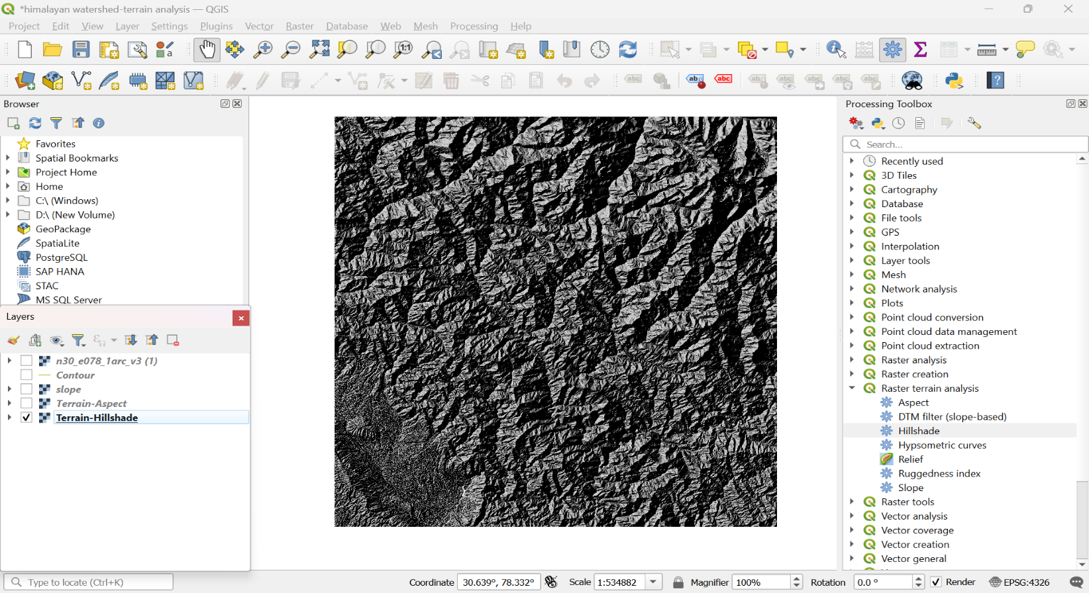
“Hill shade is a 3D visualization technique that simulates the effects of the sun’s illumination on a Digital Elevation Model (DEM). By calculating shadows and highlights based on a specific light source angle, it provides a realistic grayscale representation of the Himalayan terrain. This layer is essential for interpreting the complex physical structure of the watershed, clearly defining the ridges, ravines, and drainage patterns.”

Results
The terrain analysis reveals a high-altitude watershed with an elevation gradient from 297m to 6,535m, featuring extremely steep slopes as shown in slope and hill shade models. The aspect mapping confirms a diverse range of slope orientations, which directly creates varied micro – climates and complex drainage patterns across the Himalayan ridges.

Recommendations
Based on the high – velocity runoff and steep terrain identified, it is recommended to implement check dams in deep drainage ravines to control soil erosion. Additionally, landslide hazard mapping should be prioritized for slopes exceeding 35 degrees, and reforestation efforts should focus on north – facing aspects where higher moisture retention supports better plant survival.

Conclusion
This project successfully integrated Elevation, Contour, Slope, Aspect, and Hill shade layers to create a comprehensive “terrain fingerprint” of the Himalayan watershed. These geospatial insights provide a vital foundation for predicting water runoff and managing environment risks. This study demonstrates the power of GIS tools in interpreting complex high – altitude ecosystem for sustainable management.

Acknowledgement
I would like to express my sincere gratitude to India Space Lab for providing the opportunity to work on this pilot project. This experience has significantly enhanced my technical proficiency in QGIS and my understanding of terrain analysis in geographically sensitive regions.

